Part A

What will the following commands do?

1. **`echo "Hello, World!"`:** This command will print "Hello, World!" to the standard output.

2**. `name="Productive"`:** This command will create a variable named `name` with the value "Productive".

3. **`touch file.txt`:** This command will create an empty file named `file.txt`.

4. **`ls -a`:** This command will list all files and directories, including hidden ones, in the current directory.

5. **`rm file.txt`:** This command will remove file named `file.txt`.

6. **`cp file1.txt file2.txt`:** This command will copy the contents of `file1.txt` to `file2.txt`.

7. **`mv file.txt /path/to/directory/`:** This command will move the file `file.txt` to the directory `/path/to/directory/`.

8. **`chmod 755 script.sh`:** This command will change the permissions of the file `script.sh` to `rwxr-xr-x`.

9. **`grep "pattern" file.txt`:** This command will search for the string "pattern" in the file `file.txt` and print any lines containing that pattern.

10. **`kill PID`:** This command will terminate signal to the process with the given Process ID (PID).

11. **`mkdir mydir && cd mydir && touch file.txt && echo "Hello, World!" > file.txt && cat file.txt`:** This command will create a directory named `mydir`,

change into that directory, create a file named `file.txt`,

write "Hello, World!" to `file.txt`,

and then print the contents of `file.txt`.

12. **`ls -l | grep ".txt"`:** This command will list all files in the current directory in long format and then filter the output to show only lines containing ".txt".

13. **`cat file1.txt file2.txt | sort | uniq`:**

This command will concatenate the contents of `file1.txt` and `file2.txt`,

sort the lines alphabetically,

and then remove any duplicate lines.

14. **`ls -l | grep "^d"`:** This command will list all files and directories in the current directory in long format and then filter the output to show only lines corresponding to directories (lines starting with "d").

15. **`grep -r "pattern" /path/to/directory/`:** This command will search for the string "pattern" in all files within the directory `/path/to/directory/`.

16. **`cat file1.txt file2.txt | sort | uniq –d`:**

This command will concatenate(add) the contents of `file1.txt` and `file2.txt`,

sort the lines alphabetically,

and then print only the duplicate lines.

17. **`chmod 644 file.txt`:** This command will change the permissions of the file `file.txt` to `rw-r--r--`.

18. **`cp -r source_directory destination_directory`:** This command will copy the entire `source_directory` to `destination_directory`.

19**. `find /path/to/search -name "*.txt"`:** This command will find all files with the extension `.txt` within the directory `/path/to/search`.

20. **`chmod u+x file.txt`:** This command will add execute permission for the owner of the file `file.txt`.

21. **`echo $PATH`:** This command will print the value of the environment variable `PATH`, which contains a colon-separated list of directories where executable files are located.

Part B

Identify True or False:

1. ls is used to list files and directories in a directory. = True

2. mv is used to move files and directories. = True

3. cd is used to copy files and directories. = False (cd command is used to change directories)

4. pwd stands for "print working directory" and displays the current directory. = True

5. grep is used to search for patterns in files. = True

6. chmod 755 file.txt gives read, write, and execute permissions to the owner, and read and execute

permissions to group and others. = True

7. mkdir -p directory1/directory2 creates nested directories, creating directory2 inside directory1

if directory1 does not exist. = True

8. rm -rf file.txt deletes a file forcefully without confirmation. = True

Identify the Incorrect Commands:

1. chmodx is used to change file permissions. = chmod

2. cpy is used to copy files and directories. = cp

3. mkfile is used to create a new file. = touch

4. catx is used to concatenate files. = cat

5. rn is used to rename files. = mv

Part C

Question 1: Write a shell script that prints "Hello, World!" to the terminal.

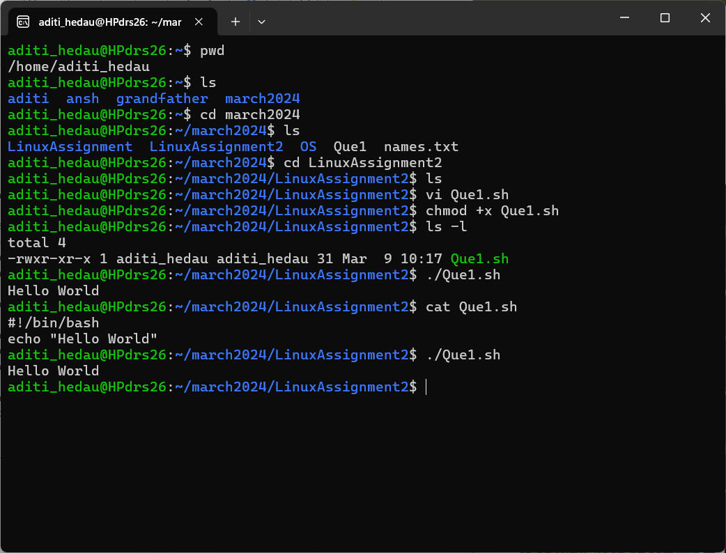

Question 2: Declare a variable named "name" and assign the value "CDAC Mumbai" to it. Print the

value of the variable.

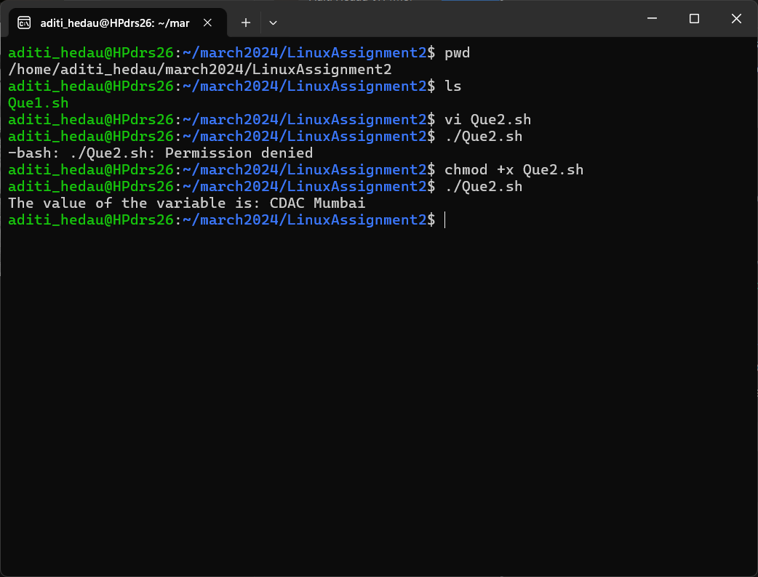

Question 3: Write a shell script that takes a number as input from the user and prints it.

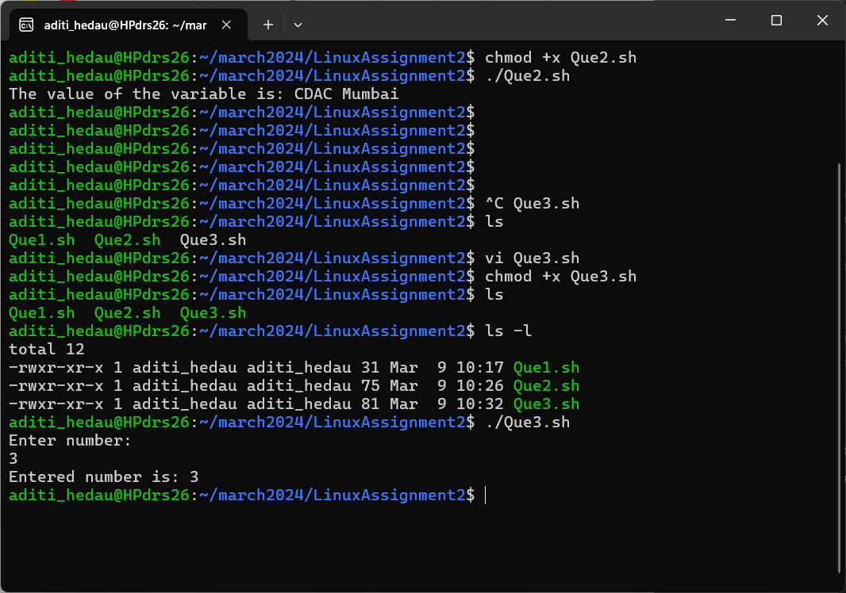

Question 4: Write a shell script that performs addition of two numbers (e.g., 5 and 3) and prints the

result.

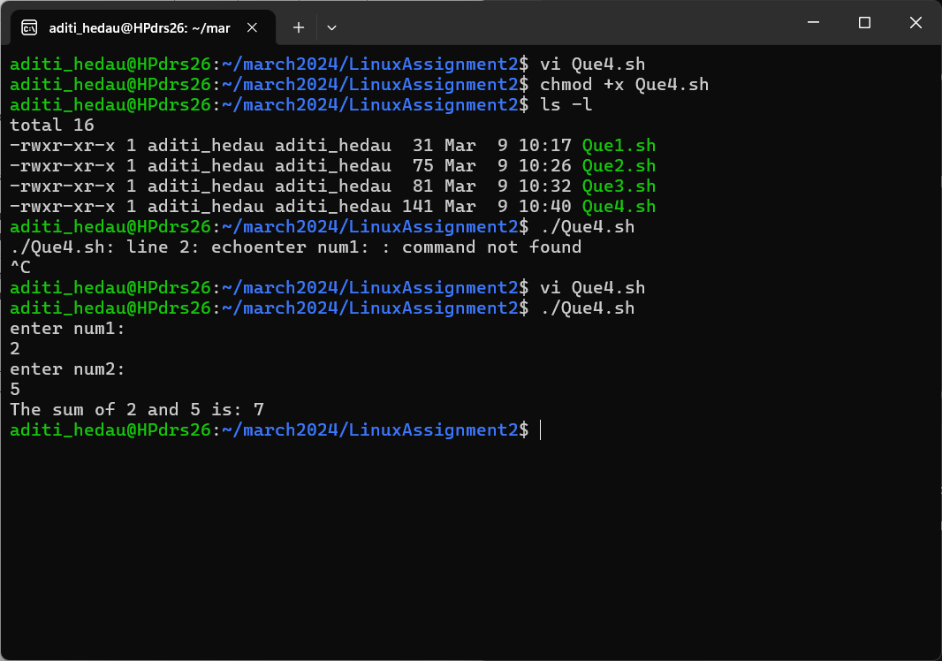

Question 5: Write a shell script that takes a number as input and prints "Even" if it is even, otherwise

prints "Odd".

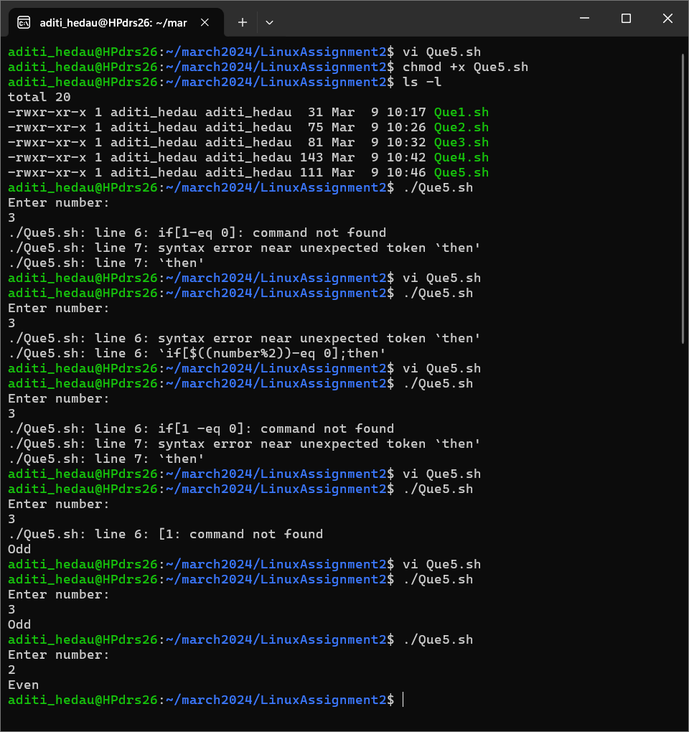

Question 6: Write a shell script that uses a for loop to print numbers from 1 to 5.

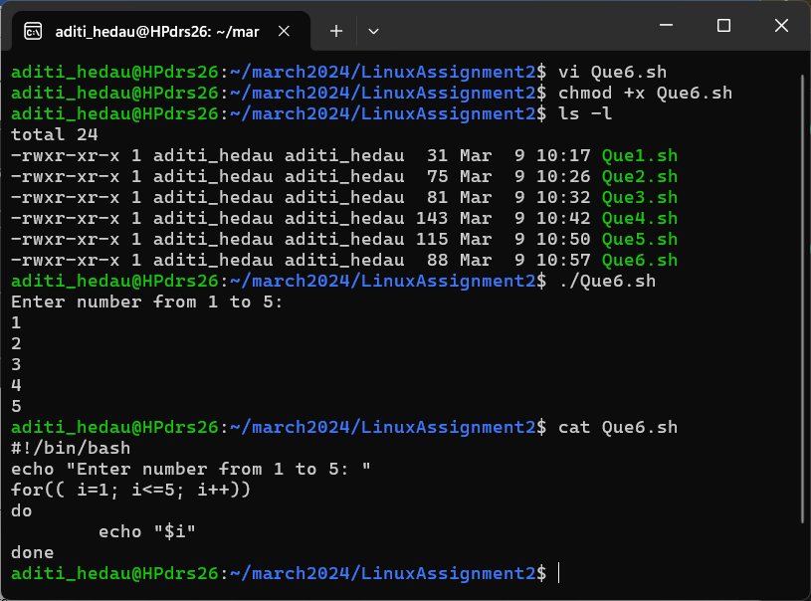

Question 7: Write a shell script that uses a while loop to print numbers from 1 to 5.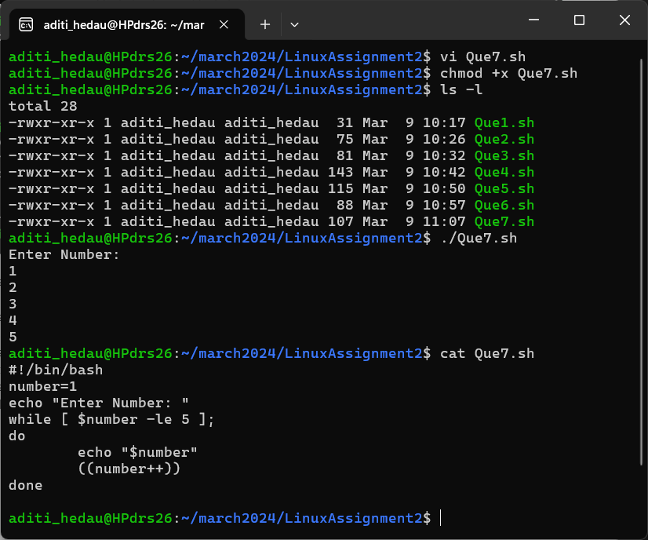

Question 8: Write a shell script that checks if a file named "file.txt" exists in the current directory. If it

does, print "File exists", otherwise, print "File does not exist".

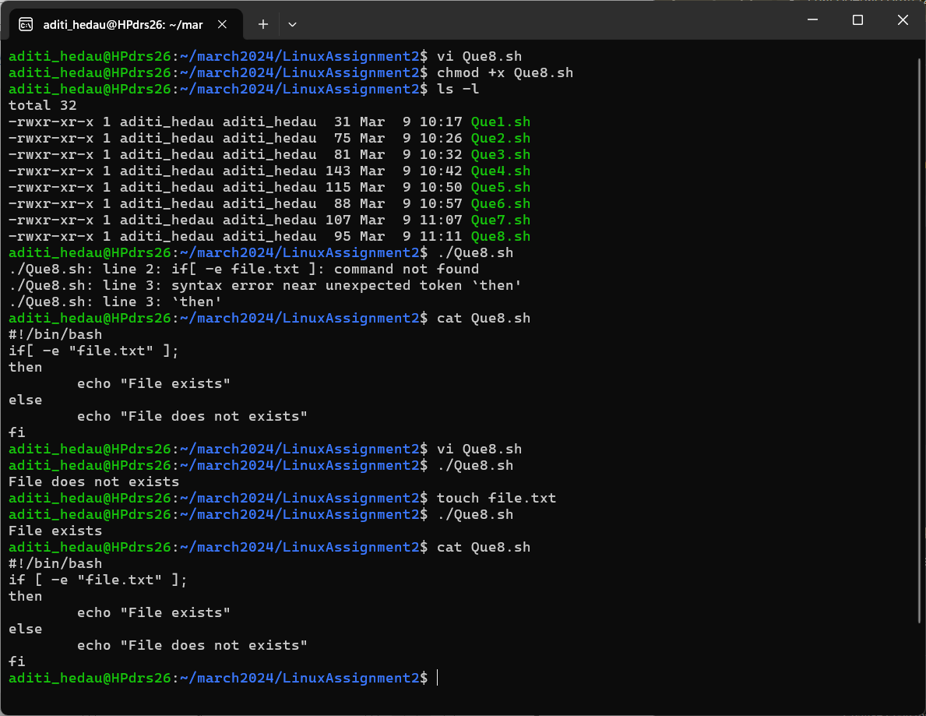

Question 9: Write a shell script that uses the if statement to check if a number is greater than 10 and

prints a message accordingly.

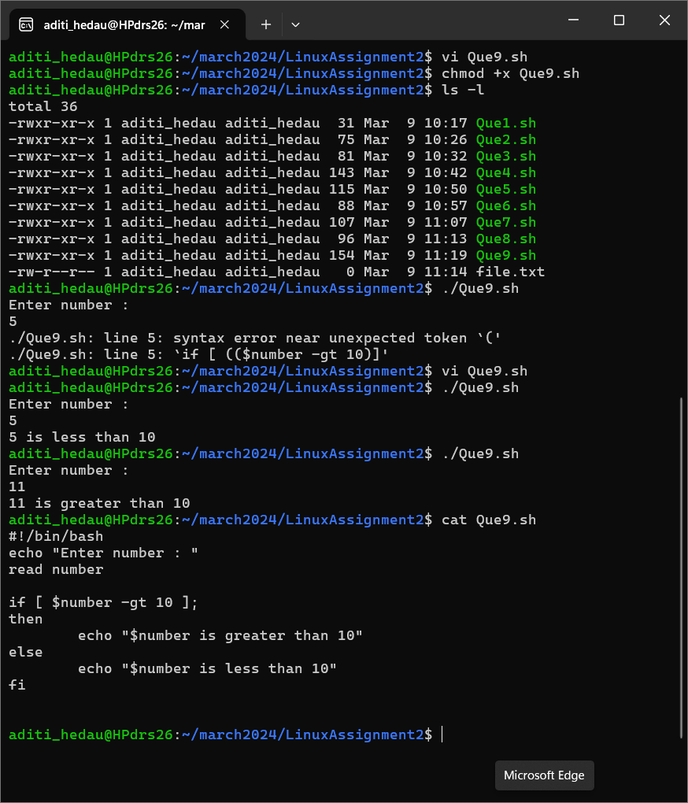

Question 10: Write a shell script that uses nested for loops to print a multiplication table for numbers from 1 to 5. The output should be formatted nicely, with each row representing a number and each column representing the multiplication result for that number

